

**SPEEDIER**

**Integrated Bite Case Management**

**Field Operations Manual**

Version 1.1

**Authors:** Mary Elizabeth Miranda, Katie Hampson, Beatriz Quiambao, Daria Manalo, Nai Rui Chng, Jobin Maestro and the RITM & FETPAFI Team

**Date:** 9 July 2019

**Table of Contents**

**Contact Information** **2**

**Introduction and Purpose** **3**

Roles 3

**IBCM** **4**

Current Procedures 4

Risk Assessments by Public Health Workers at ABTCs 6

Animal investigations by Animal Health Workers 8

Communications 12

Rabies Hotline 12

Tools and training 13

**Appendices** **14**

Update on rabies PEP 14

Checklists for Animal Investigations: 15

Investigation Equipment Checklist 15

Checklist for Investigation Procedures 16

Sample collection SOP 17

Rapid Diagnostic Test SOP 18

Paper-based Risk Assessment Form 19

Paper-based Animal Investigation form 21

# 

# **Contact Information**

The SPEEDIER project has been developed by researchers from the Field Epidemiology Training Programme Alumni Foundation Inc (FETPAFI), the Research Institute for Tropical Medicine (RITM) and the University of Glasgow, UK.

If you require any further information about the project, please contact the Principal Investigator:

Mary Elizabeth Miranda, DVM, DVPH, PHSAE

Email: megmiranda@fetpafi.org

Phone: (02) 281 2465

For further information about activities in the Province contact the local investigator:

Jobin Maestro, MD, PHSAE

Email: maestromd79@gmail.com

Phone: (+63) 917 152 5821

In case of any difficulties during IBCM work contact the Disease Surveillance Officer:

Franz Jonathan Egipto, RN, MSN

Email: fegipto.fetpafi@gmail.com

Phone: (+63) 915 761 3967

For peer support and discussion we encourage active participation on the **SPEEDIER Facebook messenger group chat for peer support**.

General information about SPEEDIER and updates on progress and events are posted on the SPEEDIER website: <https://rabiesresearch.github.io/SPEEDIER/>

# 

# **Introduction and Purpose**

**Integrated Bite Case Management (IBCM)** is a strategy that formally engages the medical and veterinary sectors (a ‘One Health’ approach) to assess the risk of genuine exposure to rabies and the subsequent need for **post-exposure prophylaxis (PEP)**. IBCM is advocated by the World Health Organisation (WHO), to ensure appropriate management of animal bite patients and reduce the costs of PEP once rabies has been controlled. IBCM has also been identified as a potential strategy that can sufficiently enhance surveillance to enable verification of rabies freedom.

The key components of IBCM are, a) **risk assessments** of exposure events by public health workers based on the clinical history of the animal involved and circumstances of the exposure and, b) linking exposure from animals deemed high-risk to **investigations** of the animal. Clear communication between human and animal health sectors on the outcomes of these two components are critical to ensure exposed victims are treated appropriately, necessary control measures are undertaken, and accurate surveillance information is reported.

Many aspects of IBCM are already operational as part of the Philippines health and veterinary system and surveillance within the National Rabies Prevention and Control Programme (NRPCP). The SPEEDIER project aims to support the implementation of IBCM to augment current practice.

In this Field Operations Manual we provide SOPs for undertaking IBCM, that are in line with the latest WHO technical guidance and adapted for the Philippines context to augment current practice. This manual contains the SOPs and copies of materials for implementing IBCM, including algorithms to guide investigations and risk assessments.

## Roles

There are 4 key roles in undertaking IBCM:

1. **Public Health Workers (PHWs)** - responsible for patient consultations and risk assessment which lead to prescription and administration of PEP, as well as reporting of information on high risk rabies exposures
2. **Animal Health Workers (AHWs)** - responsible for investigating high risk biting animals, which can lead to different management options such as quarantining, euthansia by veterinary officers, sample collection and rapid diagnostic testing as well as reporting of investigation outcomes
3. **Provincial Officers** - responsible for public health workers or animal health workers in their jurisdiction and the health information systems and control and prevention activities for the NRPCP e.g. Provincial Health Officers (PHOs) and Provincial Veterinary Officers (PVOs), as well as surveillance officers and other personnel.
4. **Laboratory Personnel** - responsible for laboratory diagnosis and reporting in their jurisdiction (regional or national level).

For a given geographic area different personnel might be assigned to these roles depending upon human resource availability and infrastructure. For example, in some areas a Barangay Health Worker may be *designated* as an AHW responsible for investigations, because there is no official AHW assigned to the Municipal Agriculture Office (MAO). Many other people may participate in the process of IBCM or may be interested in or use information from IBCM, and this involvement is valuable but these SOPs focus on the aforementioned roles.

# **IBCM**

## Current Procedures

Procedures for managing bite victims and for epidemiological investigations are outlined in Figure 1 and described as follows:

Bite victims typically present to a Rural Health Unit (RHU) where a nurse interviews them, assesses the wound (according to WHO categories I-III), provides wound cleaning and, if necessary, administers tetanus toxoid injection. Patients with either category II or III wounds are referred to an Animal Bite Treatment Centre (ABTC) for post-exposure prophylaxis (PEP); patients with category I wounds are not offered PEP. At the ABTC the rabies nurse (RN) registers the patient before the Medical Doctor (MD) prescribes PEP and refers the patient back to the RN who administers PEP, completes the National Rabies Information System (NaRIS) form and rabies registry and provides the patient with health education. The patient is required to return to the ABTC according to their PEP regimen to complete their PEP course. The updated Thai Red Cross Intradermal Regimen was formerly the recommended PEP regimen in the Philippines, but a recent administrative order updated this to the one-week 2-site ID regimen according to the latest WHO position.

If a patient presents to an RHU, an ABTC or a hospital with signs and symptoms of rabies, palliative care is provided and an investigation is conducted by the Provincial Rabies Coordinator, typically involving staff from both the Provincial Health Office (PHO) and the Provincial Veterinary Office (PVO), and recording the case in the Philippines Integrated Disease Surveillance and Response (PIDSR). If the dog/animal has been killed the veterinarian is expected to collect a sample and submit it to the regional laboratory for diagnostic services.

**Figure 1. Procedures for patient management and epidemiological investigations**

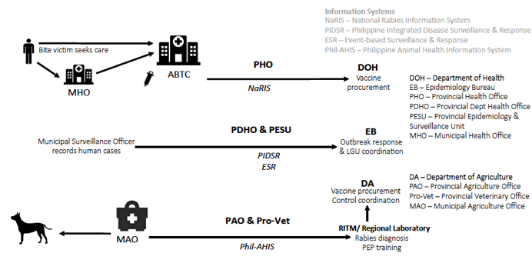

IBCM procedures to augment existing surveillance and patient management are shown below (Figure 2, italicized red font and arrows indicating communication channels):

**Figure 2. Procedures for IBCM.** Augmentation of current procedures are shown in red.

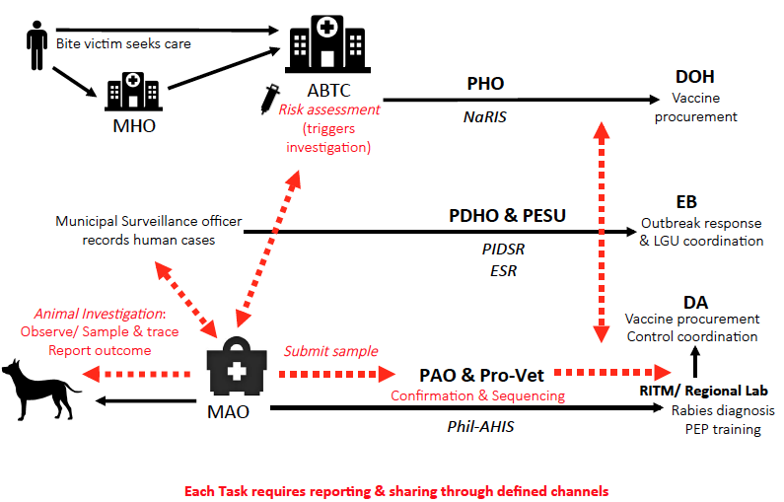

## Risk Assessments by Public Health Workers at ABTCs

When a new bite patient presents to an ABTC a risk assessment should be completed using the tailored **mobile phone-based application (App)** to ensure rapid, accurate and standardized recording. The risk assessment comprises questions to assess the biting animal’s vaccination history, if known; the animal’s outcome (alive or dead or disappeared) following the bite and its health status, as well as the category and severity of the bite (***Appendix - Risk Assessment form***). On submission of risk assessment forms alerts are automatically generated for ‘high-risk’ bites, which should trigger an investigation by the animal health worker. ‘High-risk’ bites involve animals that die, are killed, disappear or show specific signs of illness after the bite and therefore are considered suspect for rabies. The subsequent investigation should in many cases be able to evaluate if the responsible animal was rabid and should inform rabies control and prevention activities. Risk assessments should also be undertaken for patients presenting with clinical signs of rabies, also using the IBCM App, with other procedures for the patient carried out as per current practice. All other aspects of the patient consultation remain the same.

Steps to be undertaken when a bite patient presents are:

1. Carry out **risk assessment (Figure 3)** using the App (usually done by a nurse).

***If for any reason, the phone/ App is not functional the paper-based risk assessment form should be completed for later entry and submission.***

1. Review risk assessment to confirm the biting animal status and prescribe PEP (usually done by a doctor).
2. Administer PEP (usually done by a nurse).
3. Submit the risk assessment form using the app so that for “high-risk” bites an alert is generated to trigger an investigation.
4. Take necessary actions for *high-risk* versus *low-risk* bites:
   1. Immediately follow up each *high-risk* bite with a direct call to the designated AHW (Livestock Technician at the MAO or Barangay Health Worker) to confirm that they will investigate and have all the necessary details to do so.
   2. For animals available for observation that are considered *low-risk*, request the patient to observe the animal for 10 days and to immediately report back via the ABTC hotline if any changes in health are observed.
5. Issue PEP certificate to patients indicating the ABTC hotline that they should use in the event of observing any signs of illness in the dog, or for other advice on first aid and PEP (Figure 4).

**Figure 3. Clinical risk assessment algorithm to determine the status of the biting animal and recommended action.**

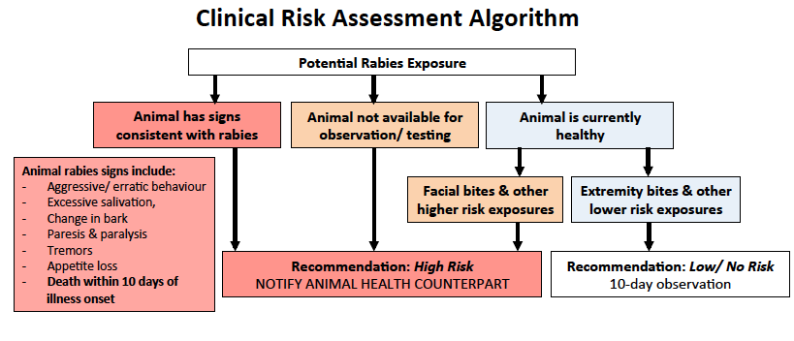

**Figure 4. Advice for bite patients and animal owners following a bite patient consultation.** Ideally this information should be printed as part of the vaccination certificate.

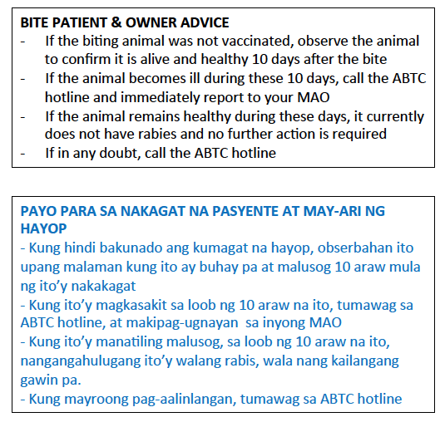

## 

## Animal investigations by Animal Health Workers

When a *designated* AHW receives an alert of a *high-risk* bite, they should investigate immediately (always within 24 hours) following the **investigation algorithm** (Figure 5). Two checklists should be reviewed: 1) the investigation procedure and 2) equipment compiled before departure for the investigation (***Appendix - Investigation checklists***). Wherever possible, the AHW should conduct a field investigation, involving a visual inspection of the animal, recording details via the App, before deciding on a course of action. At the end of the investigation the completed form should be submitted via the App and the PHW called to report the investigation result to guide patient management. The PVO and PHO should also *always* be called if the animal is probable rabid, so as to guide subsequent control activities.

If an animal is suspected to be rabid a sample should be collected and tested immediately with a **Rapid Diagnostic Test (RDT).** If the animal is not already dead, the PVO should be sought to euthanize the animal. After RDT testing the sample should be sent directly to the nearest laboratory (regional laboratory or RITM) for confirmatory testing and sequencing of positive cases. Further interviews should be conducted with the bite victim (or witnesses) and other persons or animals bitten, even if the biting animal cannot be found. For all bitten persons/ animals, contact details should be recorded and advice provided on PEP. This may identify other bite victims who have not sought care and is therefore of critical importance. Alternatively, if the biting animal is alive and not vaccinated and not suspect for rabies, a quarantine notice should be issued and the owner should ensure the dog is home quarantined for 10 days (***Figure 8, Quarantine Notice***) to confirm the animal’s condition. If at any point during the quarantine the dog shows signs of illness the owner should immediately contact the AHW. The AHW should check the animal every 3 days (by phone call is fine but if no response is received, a visit may be required).

**Figure 5. Animal Investigation Algorithm to evaluate the animal status and determine recommended actions.**

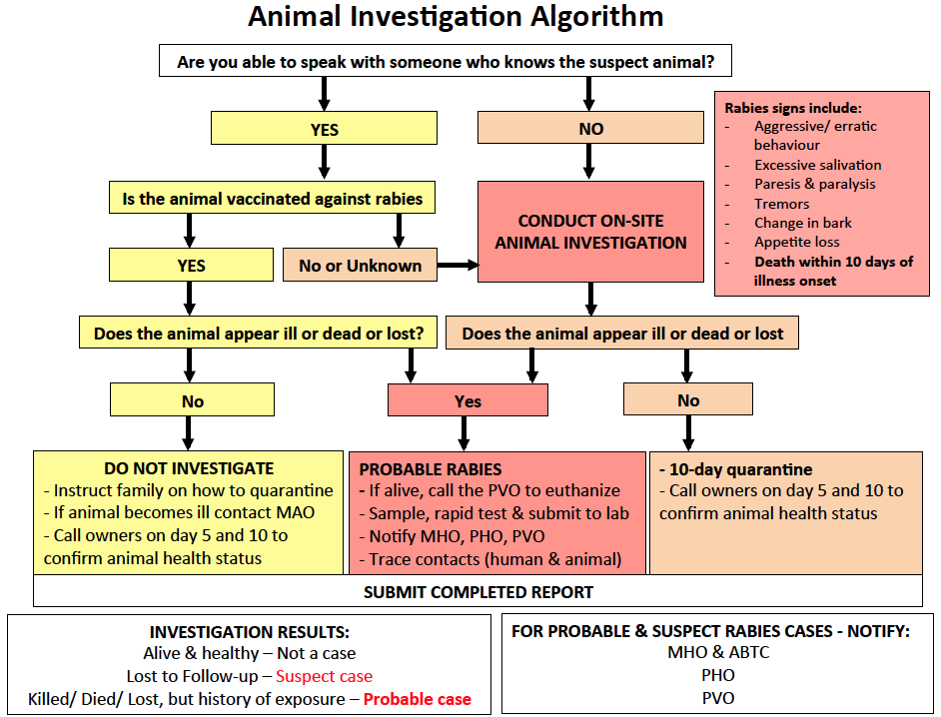

Steps to be undertaken for an investigation are:

1. Review the checklists and prepare equipment
2. Follow up with the patient by phone if possible to initiate the investigation following the questions on the App, and to see if a field investigation is necessary
   1. If the patient cannot be reached by phone, follow up directly with a site visit to track down the patient and animal
3. Visit patient and/ animal owner to complete the investigation
   1. Undertake a visual check of the biting animal
   2. Record the circumstances of the bite and details of the animal behavior and health according to criteria from the investigation form (***Appendix - Animal Investigation Form***), administered via the App. ***If for any reason, the phone/App is not functional the paper-based investigation form should be completed for later entry and submission.***
4. Decide on a course of action:
   1. If the animal is suspected to have rabies and displays clinical signs compatible with rabies, notify the PVO
      1. Request support to immediately euthanize the animal if it is alive.
      2. If the animal is dead or following euthanasia, collect a sample using the RITM recommended technique (***Appendix - Sample collection SOP***)and carry out the rapid diagnostic test (***Appendix - Rapid Diagnostic testing SOP***), recording the result on the investigation form (via the App).
      3. Conduct further interviews with bite victim(s), witnesses, and any other persons or animals (owners) who were bitten and record on the investigation form, even if the biting animal cannot be found. For all bitten persons/ animals, record contact details and provide advice (Figure 6) and follow procedures for in-contact animals (Figure 7).
   2. If animal is alive and not vaccinated, request the owner to home quarantine the dog for 10 days. Issue a quarantine notice (***Figure 8, Quarantine Notice***) to confirm the animal’s condition and ensure adherence.
      1. The owner should contact the AHW if at any point during home quarantine the dog shows signs of illness and procedures should be followed for a rabid animal (4a).
5. On completion of the investigation, submit the investigation form via the App. This will create and send an automated summary to the RHU and ABTC. ***If for any reason, the phone/App is not functional save the paper-based investigation form for later entry.***
6. Call the corresponding public health worker to notify them of the investigation result and call the PVO and PHO immediately if the animal is suspect for rabies

**Figure 6. Advice for persons identified who have been bitten by an identified suspect rabid animal.**

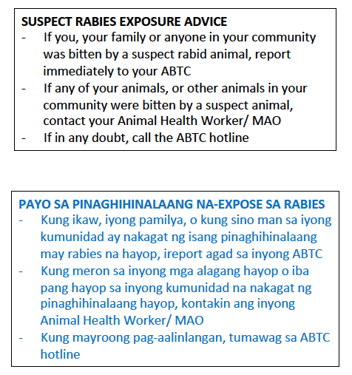

**Figure 7. Procedures to follow for animals identified to have been in contact with a suspect animal.**

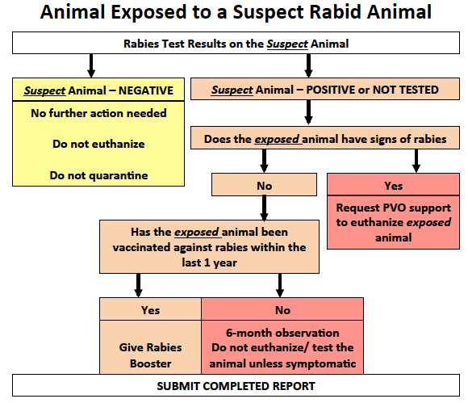

**Figure 8. Quarantine Notice to be administered to dog owners for dogs that have not been vaccinated and require observation.**

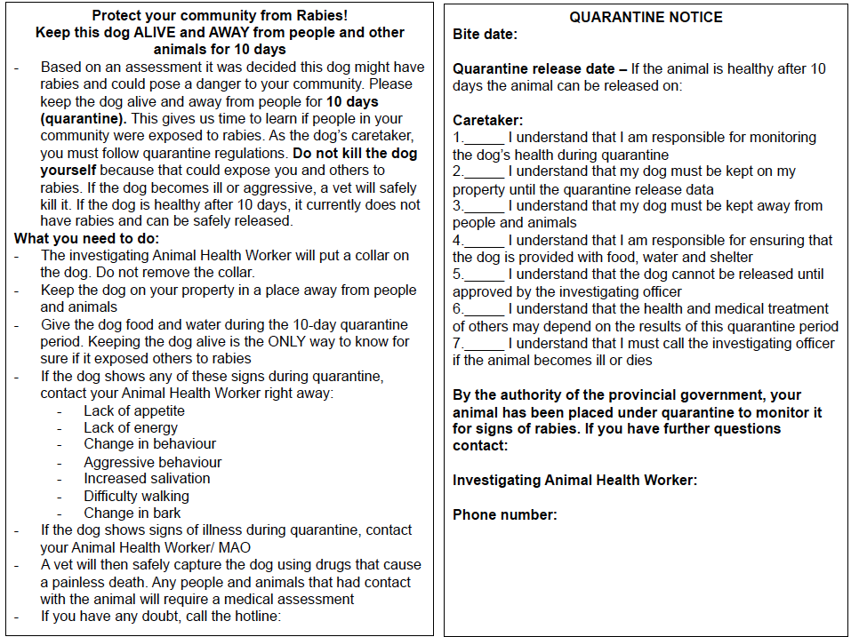

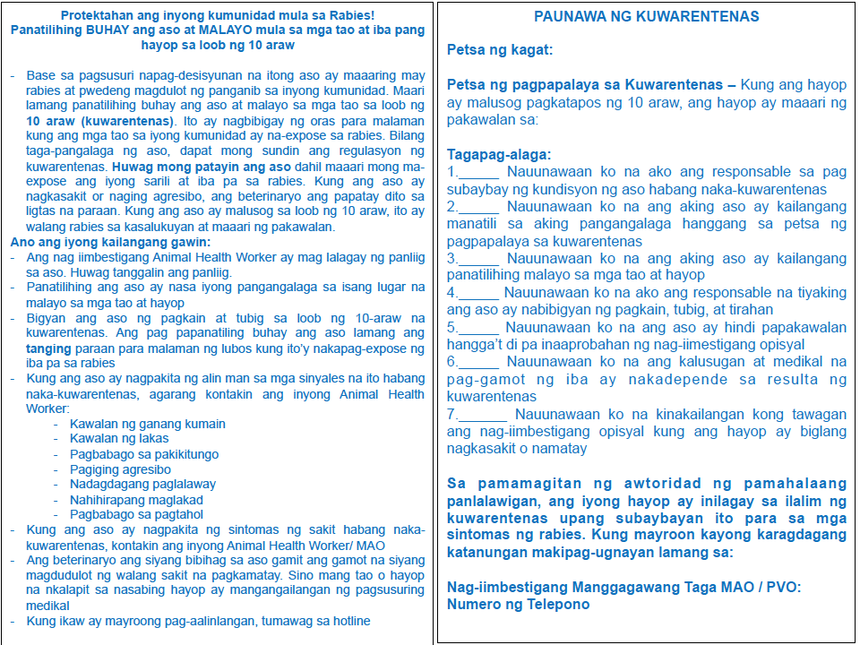

## Communications

Communications between PHWs, *designated* AHWs, Provincial Officers and Laboratory personnel is crucial to the success of IBCM. The App aims to facilitate communications between personnel, but phone calls and face-to-face communications are essential for effective IBCM. The different communication channels that should be followed are outlined in Figure 9.

During implementation of IBCM, if any difficulties are encountered, you should contact your **Disease Surveillance Officer** for advice (see page 2).

**Figure 9. Flow of information and communication channels for IBCM implementation**

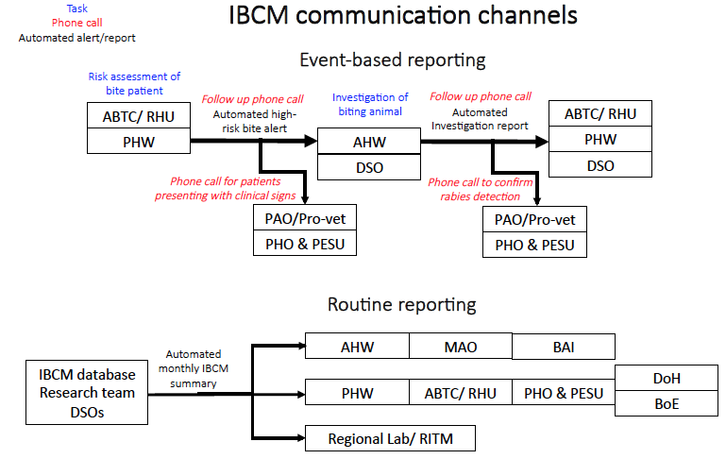

## Rabies Hotline

Every ABTC should have an emergency hotline, which members of the public can call should they have concerns about animal bites or rabies as well as other emergencies. This number should be recorded on patient consultation/ vaccination cards. A register or counter book should be used to record all calls to the hotline and serve as a source of information about common questions or concerns. Subsequent review or analysis of this log should inform rabies IEC materials for use locally or for guiding establishment of IBCM elsewhere.

The register should include: the date and time, the caller’s name and telephone number (in case they need to be called back and directed to a source of PEP for example), the problem the caller rang about, the suggested solution or response and the name of the call receiver.

## Tools and training

The App should be used to guide and record risk assessments and animal investigations. The application is installed onto mobile phones or tablets for use in the field, or where, available laptops, for example at Municipal Offices and ABTCs. The training programme includes lectures within instruction on how to use the App.

Vaccination cards should be issued to patients indicating the hotline number for the ABTC that patients should use in the event of observing any signs of illness in the dog, or for advice on first aid and PEP (Figure 4).

The peer support group (messenger group chat) is for practitioners to share their experiences, including challenges and to solicit peer support to address them. We encourage participation in the peer support group and updates on progress will also be posted regularly.

Feedback to practitioners should be provided through regular reports summarizing the surveillance data generated by the IBCM (including categorization of exposures and cases according to WHO case definitions), and through regular stakeholder meetings to discuss interpretation of surveillance data. These data should be directly accessible via the IBCM dashboard. Users log in to the dashboard (<http://rabies.esurveillance.or.tz/login>) with their App credentials (username and password).

Updates will also be available via the SPEEDIER website: <https://rabiesresearch.github.io/SPEEDIER/>

The training programme for IBCM also includes useful information including:

1. Updates on rabies PEP regimens (**Appendix - PEP update**)
2. Lectures on rabies epidemiology, on the national, regional and local situation of rabies situation, on rabies prevention, control and surveillance and specifically on IBCM including the App and dashboard, sample collection and testing and SOPs
3. Surveillance forms

# 

# **Appendices**

### Update on rabies PEP

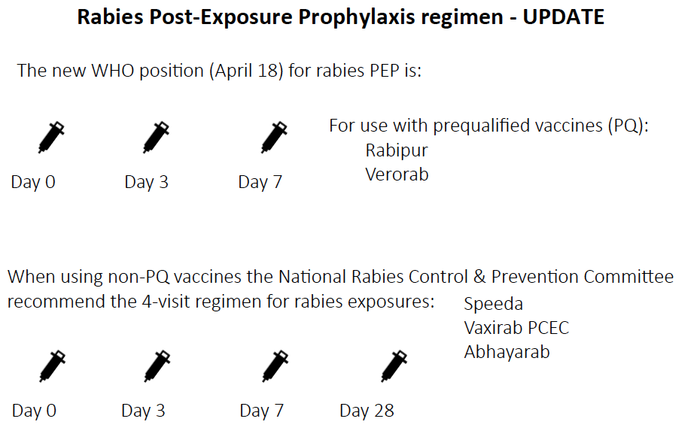

### Checklists for Animal Investigations:

#### Investigation Equipment Checklist

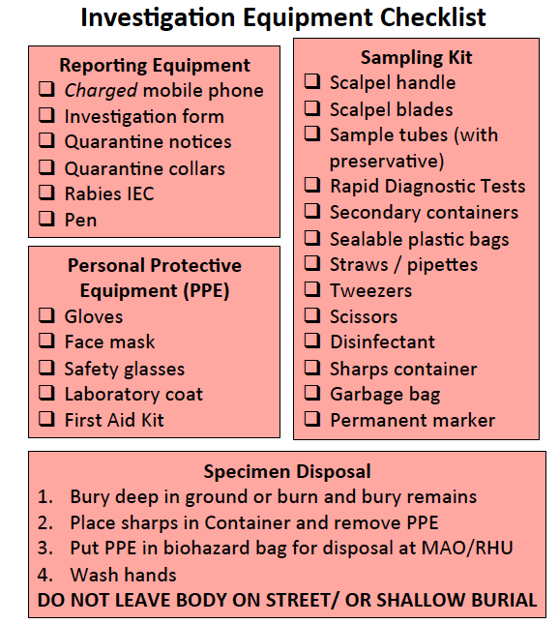

#### Checklist for Investigation Procedures

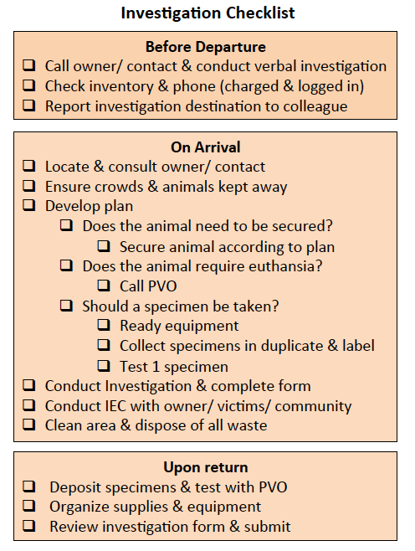

### 

### Sample collection SOP

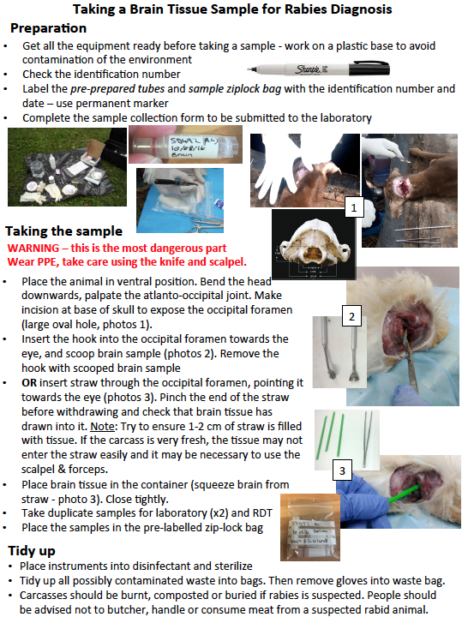

### 

### Rapid Diagnostic Test SOP

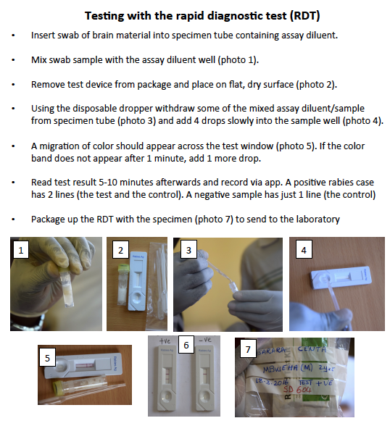

### 

### 

### Paper-based Risk Assessment Form

**Risk Assessment form**

Public Health Workers (usually nurses) complete risk assessments during patient consultations that are then confirmed by Medical Doctors will confirm:

ABTC PHW Date of consultation

Patient name Age Sex

Phone number Patient ID

MunicipalityBarangay

Type of consultation (multichoice):

PEP initiation (d0), dose 2 (d3), dose 3 (d7), dose 4 (d28), rabies signs

Was the patient referred (Y/N) If yes, from where?

*Bite history (first visit ONLY)*

Date bitten Biting animal *Select:* dog, cat, livestock, other (specify)

Bite site (tick those that apply)

☐ Head/neck ☐ Trunk ☐ Arms/Hands ☐ Legs/ Feet ☐ Other – specify

Bite details (tick those that apply)

☐ Scratch ☐ minor wounds ☐ large wounds

☐ severe wounds (hospitalization required) ☐ Other route of exposure - specify

Category of bite ☐ I ☐ II ☐ III

*Risk Assessment (first visit ONLY)*

Is the animal known in the community? If yes, owner Barangay

Is the animal vaccinated (Y/N) If yes (tick all that apply): ☐ In last 12 months ☐ At least 2x

Animal signs (tick those that apply)

* Unprovoked aggression (incl. biting/gripping people/ animals/ objects)
* Excessive salivation
* Unexplained dullness/lethargy
* Paresis and/or paralysis
* Tremors
* Appetite loss
* Abnormal vocalization
* Restlessness
* Running without reason
* Feeding young
* Eating
* Normal behavior
* None of the above

Circumstances of bite (tick those that apply)

* Noise (speaking/shouting)
* Running
* Aggressiveness
* Scared of dogs
* Throwing things at dogs
* Playing
* Approaching the dog
* Animal not provoked
* None of the above, specify

Environmental conditions (tick those that apply)

* Chained
* Fenced
* Lots of dogs
* Lots of people
* At the owners property
* Animal came from unknown place
* None of the above, specify

Is the animal still alive? Yes/No (select)

Rabies Assessment decision (tick): Healthy/ suspicious for rabies/ sick - not rabies/ unknown

Has the patient already consulted the MAO/PVO (Y/N)?

Actions taken by patient/ family

☐ None ☐ wound washing ☐ Traditional Medicine (specify)

Recommended treatment for patient

☐ None ☐ Wound washing ☐ Tetanus ☐ Antibiotics

☐ Rabies vaccine recommended ☐ Immunoglobulin recommended

Is PEP available - *FOR ALL VISITS*

☐ Rabies vaccine & Immunoglobulin ☐ Rabies vaccine only

☐ Immunoglobulin only ☐ None

PEP administered to patient - *FOR ALL VISITS*

☐ ERIG ☐ HRIG

☐ Abhayarab ☐ Rabipur ☐ Speeda ☐ Vaxirab PCEC ☐ Verorab ☐ Other-specify

Comment (if any) – *FOR ALL VISITS*

A bite is considered ‘High-risk’ and therefore requires an investigation ***if*** the animal died, was killed or disappeared after the bite *or* was alive but showed signs of illness.

Upon submission of the risk assessment an alert should be sent automatically to the AHW to trigger the investigation. The PHW should also directly call the AHW to explain the case (also as back up for the alert). The generated alert contains the patient details, barangay and phone number and the dog owner name if available. The patient should also be given their vaccination card detailing the vaccination schedule and the ABTC hotline for the patient to call in the event of any concerns, including if the biting animal becomes ill.

### Paper-based Animal Investigation form

**Animal Investigation Form**

Animal Health Workers (AHWs) complete investigations if alerted of a high-risk bite from the ABTC or on request due to a suspect rabid animal:

AHW Municipality Barangay Date of investigation

Type of investigation: ☐ Phone consultation ☐ In-person investigation

Investigation trigger: ☐ ABTC/PHW, ☐ MAO/PVO, ☐ community, ☐ other (specify)

Reason for investigation *(Tick)*:

* human exposure (bite/scratch)
* suspect rabid animal
* hit by car
* found dead
* sick animal
* sick person (human rabies case)
* other (*specify*)

Biting Animal - *Select* ☐ dog ☐ cat ☐ livestock ☐ other (specify)

Was this animal: ☐ Unowned ☐ Owned ☐ Unknown

If owned, name of owner

Is the investigation linked to a patient exposure (Y/N): If yes, patient ID

Number of people bitten: Name of bite victim(s):

PEP status *(Tick)*:

* PEP initiated (1st dose received)
* PEP completed
* PEP not sought – advised to seek - URGENT
* Seeking PEP (1st dose not received) – URGENT
* PEP not advised

Other animals bitten (tick all that apply) ☐ dog ☐ cat ☐ livestock ☐ other

Specify details

Was the biting animal found (Y/N)

Animal outcome *(Tick)*: ☐ Alive ☐ Dead ☐ Disappeared

If dead, cause of death *(Tick)*:

* killed by owner/ by community
* killed by animals
* hit by car
* illness
* unknown

Animal age *(Tick)* ☐ Pup <3 mths ☐ juvenile <1y ☐ Adult >1y ☐ Unknown

Animal sex *(Tick)* ☐ Male ☐ Female ☐ Unknown

Is the animal vaccinated (Y/N) If yes (tick all that apply): ☐ In last 12 months ☐ At least 2x

Animal signs (tick those that apply)

* Unprovoked aggression (incl. biting/gripping people/ animals/ objects)
* Excessive salivation
* Unexplained dullness/lethargy
* Paresis and/or paralysis
* Tremors
* Appetite loss
* Abnormal vocalization
* Restlessness
* Running without reason
* Feeding young
* Eating
* Normal behavior
* None of the above

Circumstances of bite (tick those that apply)

* Noise (speaking/shouting)
* Running
* Aggressiveness
* Scared of dogs
* Throwing things at dogs
* Playing
* Approaching the dog
* Animal not provoked
* None of the above, specify

Environmental conditions (tick those that apply)

* Chained
* Fenced
* Lots of dogs
* Lots of people
* At the owners property
* Animal came from unknown place
* None of the above, specify

*Investigation recommendation (tick):*

* Healthy, observe for 14 days
* sick - not rabies, observe for 14 days
* unknown – quarantine for 14 days
* suspect for rabies – quarantine for 14 days or sample

Was a sample collected (Y/N)? If yes, date of sample collection

* If no, why not:
* Animal not found
* Animal decomposed
* Carcass disposed of in unknown location
* Carcass burned
* Carcass consumed
* NA

Location where sample stored: ☐ MAO ☐ PVO ☐Investigator house ☐ other (specify)

Was a rapid test performed? (Y/N)

Test Results: ☐ Positive ☐ Negative ☐ Inconclusive ☐ Unsatisfactory for testing

Comments if any

On completion of the investigation, the AHW provides advice to the animal owner(s) and the general community on rabies prevention, including the need for dog vaccination, and to seek and complete PEP in the event of a bite by a suspect rabid animal.

If the investigation indicates a rabid dog, the AHW should also inform the barangay captain and all at-risk persons and animal owners of appropriate action, including urgent health seeking for those who were exposed but had not initiated PEP.

In the event of other people or animals being bitten by a suspect rabid animal, these people/animals should also be visited to provide advice and to complete additional investigations (see IBCM protocol).

Before departure, the AHW should confirm with the animal owner the urgent need to contact the AHW should any behavior changes be observed in the animal.

Information from the investigation should be sent back to the ABTC giving the result/animal status and forewarning of exposures likely to attend the ABTC as well as verifying those who have already sought care.

If the investigation was not initiated by an alert from the ABTC but instead by a community member or direct from the PVO, the nearest ABTC and RHU should be alerted to inform them of any high-risk bites identified and persons who are required to seek PEP.

The AHW should either:

a) submit samples collected to the PVO within 24 hours or to the regional laboratory if closer; or

b) alert the PVO that an animal shows clinical signs consistent with rabies and their support is needed to the euthanize the animal. In this case the PVO (or representative) would collect and submit the sample. If the PVO does the investigation themselves, they should arrange for the sample to be sent to the regional laboratory for confirmation and sequencing.